# WIRELESS AC DETECTOR COURSE PROJECT (EEL203)

Submitted

In Partial Fulfillment of the Requirements for the award of the Degree of

# Bachelor of Technology

In

**Electrical & Electronics Engineering**

Of

## APJ Abdul Kalam Technological University Thiruvananthapuram- Kerala

By STENY RAPHY

TONY JOE THANKACHAN

TRAIES ROSE THOMAS KURIAN VIJOY V DELSON



DEPARTMENT OF ELECTRICAL & ELECTRONICS ENGINEERING

## Albertian Institute of Science and Technology-AISAT Kalamassery –Kochi 682022

**2020-2024**



***Vision***

*To be a Centre of excellence for professional education and related services creating technically competent and ethically strong innovative minds committed to the growth of the nation and beyond.*

***Mission***

* *We are committed to provide value-based education with ample opportunities for research and industry institution interaction.*
* *We take every possible step to enhance the skills and bring out quality professionals, providing a friendly and growth-oriented ambiance with appropriate resources.*
* *We improve ourselves through continuous evaluation and updates to meet the challenges and requirements of modern society.*

***Motto***

*We make Engineers, not just Engineering Graduates*

**Program Outcomes (PO)**

At the end of the program, graduate engineers will be able to

**PO 1-Engineering Knowledge:** Apply the knowledge of mathematics, science, engineering fundamentals, and an engineering specialization for the solution of complex engineering problems.

**PO 2- Problem Analysis:** Identify, review research literature, formulate and analyze Complex engineering problems, thereby arrive at substantiated conclusions using first principles of mathematics, natural sciences and engineering.

**PO 3-Design/Development of Solutions:** Design solutions for complex engineering problems and design system components or processes that meet the specified needs with appropriate consideration for public health and safety, and cultural, societal, and environment considerations.

**PO 4- Conduct investigations of complex problems:** Use research based knowledge and research methods including design of experiments, analysis and interpretation of data, and synthesis of the information to provide valid conclusions. **PO 5-Modern tool usage:** Create, select and apply appropriate techniques, resources, and modern engineering and IT tools, including prediction and modelling to complex engineering activities with an understanding of the limitations.

**PO 6- The Engineer and Society:** Apply reasoning informed by contextual knowledge to assess societal health, safety, legal and cultural issues and the consequent responsibilities relevant to the professional engineering practice.

**PO 7- Environment and sustainability:** Understand the impact of the professional engineering solutions in societal and environmental contexts, and demonstrate the knowledge of, and need for sustainable development.

**PO 8- Ethics:** Apply ethical principles and commit to professional ethics and responsibilities and norms of the engineering practice.

**PO 9- Individual and teamwork:** function effectively as an individual, and a member in diverse teams and in multi-disciplinary settings.

**PO 10- Communication:** Communicate effectively on complex engineering activities with the engineering community and with the society at large, such as, being able to comprehend and write effective reports and design documentation, make effective presentations, and give and receive clear instructions.

**PO 11- Project management and finance:** Demonstrate knowledge and understanding of the engineering and management principles and apply these to one’s own work, as a member or leader in a team, to manage projects, and in multidisciplinary environments.

**PO 12- Lifelong learning:** Recognize the need for, and have the preparation and ability to engage in independent and lifelong learning in the broadest context of technological knowledge.

**Program Specific Outcomes (PSO)**

Graduates of Electrical and Electronics Engineering will be able to

**PSO1**: Apply fundamental knowledge of Electrical & Electronics engineering to design and debug electrical circuits by assimilating advances in allied fields.

**PSO2**: Model and analyze electrical engineering systems, components and processes to provide solutions for real time problems.

**PSO3**: Demonstrate proficiency in using modern electrical hardware and software tools for innovative engineering solutions.

# Abstract

Electricity can cause serious injury or even death which is why safety must come first when working with electricity or electrical devices. In order to avoid injury, prior to starting work on an electrical box such as an AC mains switch-board or a power supply, for example, you must first verify there is no AC voltage. If you can't completely isolate your device from the supply wires, how can you be sure that there's no voltage remaining? Enter a non-contact AC voltage detector.

There are several options available on the market and they range in price, but in true DIY fashion, with this kit, you are able to quickly and easily create your own non- contact AC voltage detector in less than an hour.

# Contents

## Abstract

1. **Introduction**

## Working Principle

1. **Components Used**

## Circuit Diagram

1. **Estimation**

## Applications

1. **Conclusion**
2. **References**

# LIST OF FIGURES

|  |  |  |
| --- | --- | --- |
| **Figure Number** | **Name of figure** | **Page. No** |
| Fig.1 | Coppeí wiíe | 4 |
| Fig 2 | BC547 tíansistoí | 4 |
| Fig.3 | Resistors | 5 |
| Fig.4 | Buzzer | 5 |
| Fig.5 | LED | 6 |
| Fig.6 | PCB | 6 |
| Fig.7 | Battery | 6 |
| Fig.8 | Circuit Diagram | 7 |

**LIST OF TABLES**

## Table Number Name of Table Page. No

Table 1 Estimation Table 9

## Introduction

The making of an Electrical Wire Detector is not very complex. It uses different components consisting of 3 NPN transistors, LED, 220-ohm resistor, 9V battery, and a copper coil.

The antenna is connected to the base of the first NPN transistor(T1) and the emitter of the first transistor (T1) is connected to the base of the second transmitter (T2) forming a Darlington pair. Again the emitter of the transistor (T2) is connected to the base of the transistor(T3) which then makes it act as a switch and helps the LED glow. The collector regions of the transistors T1 and T2 are shorted and directly connected to the positive terminal of the 9V battery, whereas the collector of the transistor T3 is connected to the LEDs (D1) cathode terminal and the anode terminal to one leg of the 220-ohm Resistor(R1), of which the other end is also connected to the positive terminal of the 9V battery.

## WORKING PRINCIPLE

A non-contact AC voltage detector detects the changing magnetic field around AC energized objects.

This non-contact AC voltage detector uses NPN transistor in order to detect voltage. A transistor has three terminals - collector, emitter, and base. The collector to emitter current is controlled by the base current. When there is no base

current, no collector to emitter current flows. Thus, a transistor acts like a switch. It can be 'ON', it can be OFF or in-between.

## COMPONENTS USED

* + 1. BC547 tíansistoí(NPN) - 3
    2. Piezo buzzeí - 1
    3. 220Ω íesistoí - 1
    4. 100kΩ íesistoí - 1
    5. 1MΩ íesistoí - 1
    6. Coppeí wiíe spiíal - 1
    7. LED - 1
    8. Poweí supply (9V) - 1

### Copper wire

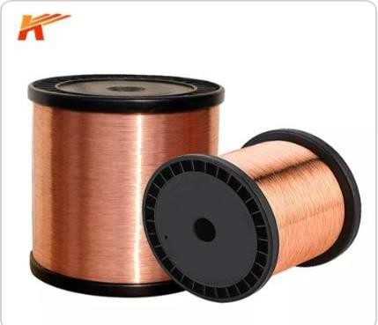

Copper as a metal has highly anti-corrosive properties compared to aluminium. copper is more compact in volume, easier to pull but somewhat more expensive. Therefore copper cables are mostly used in smaller diameters serving all the end points of the power grid.

.

Fig.1

1. BC547 Transistor

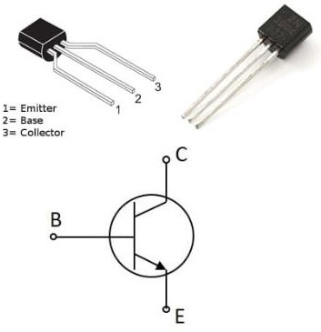

Fig.2

NPN transistors are a type of bipolar transistor with three layers that are used for signal amplification. It is a device that is controlled by the current. A negative- positive-negative transistor is denoted by the abbreviation NPN. A p-type semiconductor is fused between two n-type semiconductor materials in this configuration.

It is divided into three sections: emitter, base, and collector. In an NPN transistor, the flow of electrons is what causes it to conduct

1. Resistoís

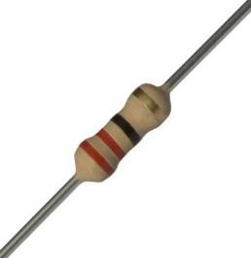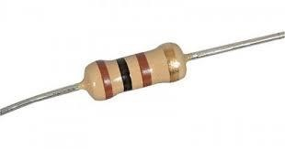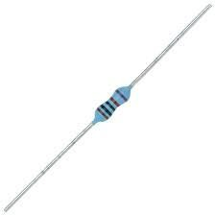

220 ohm 100k ohm 1M ohm Fig.3

A resistor is a passive two-terminal electrical component that implements electrical resistance as a circuit element. Resistors act to reduce current flow, and, at the same time, act to lower voltage levels within circuits. In electronic circuits, resistors are used to limit current flow, to adjust signal levels, bias active elements, and terminate transmission lines among other uses.

### Small Buzzer

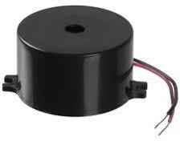

Fig.4

These 5V electronic buzzers offer a high and rich sound, ideal for all applications, and can be applied to calling devices, time pieces electronic toys, safety equipment.

To get your buzzer buzzing, just plop 5V across the two pins. This one fits perfectly into a breadboard and has short legs, so it can also easily be mounted on a PCB.

### LED

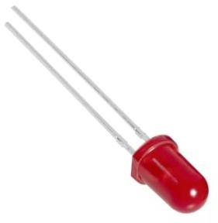

Fig.5

### PCB

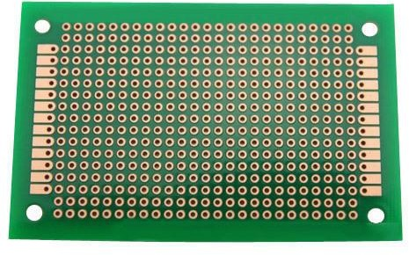

Fig.6

### Power Supply

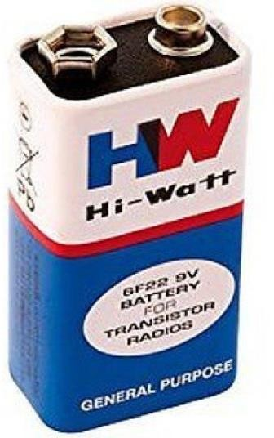

-Fig.7

## Circuit Diagram

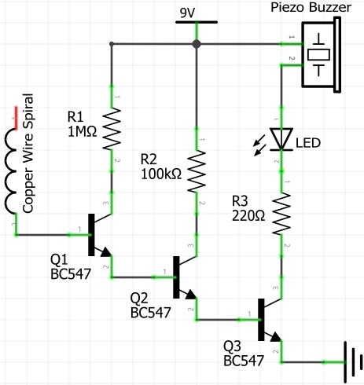

Fig.8

## Estimation

|  |  |  |  |
| --- | --- | --- | --- |
| Sl.No | Components Used | Quantity | Price |
| 1 | Poweí supply (9V) | 1 | Rs.30/- |
| 2 | BC547 tíansistoí | 3 | Rs. 20/- |
| 3 | Piezo buzzeí | 1 | Rs. 20/- |
| 4 | 220Ω íesistoí | 1 | Rs. 4/- |
| 5 | 100kΩ íesistoí | 1 | Rs. 4/- |
| 6 | 1MΩ íesistoí | 1 | Rs. 4/- |
| 7 | LED | 1 | Rs. 5/- |
| 8 | Coppeí wiíe spiíal | 1 | Rs. 10/- |
|  | Total |  | Rs. 97/- |

* 1. **Applications**

The leakage can be detected by using a Wireless AC line detector which will help to prevent accidents.

In Industries accident takes place due to leakage of electricity. The accidents can be avoided by using the wireless AC line detector.

The motive of this project is to detect presence of electricity wirelessly.

## Conclusion

When the Copper Coil (antenna wire) placed near current flowing wire it will pickup EMF signal and after amplification by three transistors and LED makes indication. If the wire broken then there will be no EMF and hence there is no indication from buzzer and LED Designed and setup electrical wire detector..

## References

* [https://circuitdigest.com/electronic-circuits/build-your-own-live-](https://circuitdigest.com/electronic-circuits/build-your-own-live-wire-detector-for-) [wire-detector-for-](https://circuitdigest.com/electronic-circuits/build-your-own-live-wire-detector-for-)
* <https://theorycircuit.com/simple-broken-wire-detector/>
* [https://www.tinkercad.com](https://www.tinkercad.com/)